
Dashboard Design

Date | 24 September 2024
Team ID | PNT2022TMIDxxxxxx
Project Name | EV Market Analysis (Tableau)
Maximum Marks | 5 Marks

Creating an effective dashboard involves thoughtful design to ensure that the presented information is clear, relevant, and easily understandable for the intended audience. Here are some key principles and best practices for dashboard design
Activity 1: Interactive and visually appealing dashboards
Creating interactive and visually appealing dashboards involves a combination of thoughtful design, effective use of visual elements, and the incorporation of interactive features. Here are some tips to help you design dashboards that are both visually appealing and engaging for users so take care of below points
- Clear and Intuitive Layout
Place the five KPI cards at the top, filters on the right, and six charts in a 3 x 2 grid below. The reader sees headline numbers first, then detail.
- Use Appropriate Visualizations
Bar charts rank categories, manufacturers, regions and battery types. A scatter plot shows price vs range, and a line chart shows model-year trends.
- Colour and Theming
A single blue theme with one accent colour per measure. The palette is colour-blind friendly and used the same way on every sheet.
- Interactive Filters and Slicers
Filters for market_region, category and model_year apply to all worksheets. Clicking a manufacturer bar filters the other charts (Use as Filter).
- Drill-Down Capabilities
Drill from category to manufacturer and then to individual model_name using the hierarchy. Tooltips show price, range and sales for each vehicle.
- Responsive Design
Designed for a desktop browser at 1200 x 800. A phone layout shows the KPI cards and one chart at a time for mobile viewers.
- Custom Visuals and Icons
No custom visuals are needed. Plain KPI cards keep the dashboard fast to load with about 2 lakh rows.
- Use of Infographics
The dashboard uses KPI cards and simple bar, line and scatter charts. Heavy infographics are avoided so the numbers stay clear.

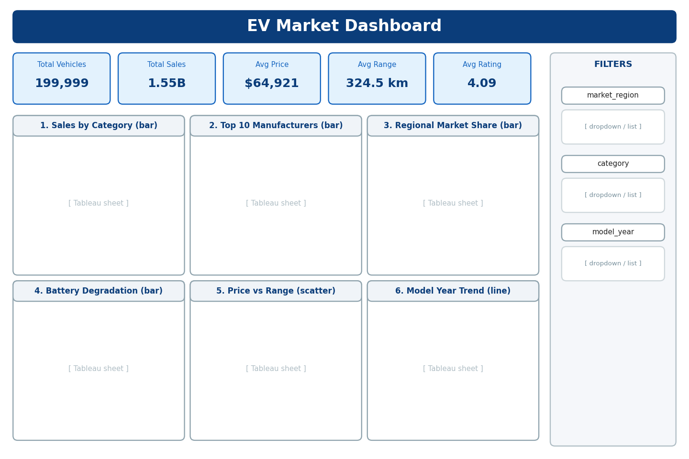
Here are five key outcomes from our EV market dashboard:
Scale: The dashboard covers 199,999 vehicles with 1.55 billion annual sales units in total, an average price of $64,921, an average range of 324.5 km and an average rating of 4.09.
Category leaders: Two-Wheeler Scooter sells the most units (about 174.6 million), followed by Hatchback (about 154.9 million). Compact SUV and Sedan are close behind at about 153 million each.
Evenly spread market: The top 10 manufacturers each sell between 8.7 and 9.5 million units, and all seven regions hold about 14% of sales each. No single brand or region dominates.
Battery health: Solid-State batteries show the lowest average 5-year degradation at 7.4%, compared with about 10% for LFP and about 14% for NMC, NCA and Sodium-Ion.
Customer use: Family Daily Use accounts for about 617 million units (about 40% of sales), followed by Urban Commute at about 27%.

Activity 2
Publish Dashboard on Tableau Public and paste the Dashboard Public link below:
[Paste your Tableau Public dashboard link here]

